*VR Headset*

Jonathan Andre Corrigeux

Technical writer, Researcher

San Jacinto College-North

Houston, United States

[johnageux@gmail.com](mailto:johnageux@gmail.com)

Cesar De La Cruz

Speaker and Researcher

San Jacinto College-North

Houston, United States

[CesarDelacruz514@gmail.com](mailto:CesarDelacruz514@gmail.com)

Gemaris Velazquez

Programmer, Researcher

San Jacinto College-North

Houston, United States

[velazquez.g920400@stu.sanjac.edu](mailto:velazquez.g920400@stu.sanjac.edu)

Alejandro De La Cruz

Researcher

San Jacinto College-North

Houston, United States

[delacruzalejandro572@gmail.com](mailto:delacruzalejandro572@gmail.com)

**Abstract**

The NASA Suits Design Challenge is for students to collaborate on research that aims to create a design that displays space suit information within an augmented reality (AR) environment. A component of that research is creating a design that records biological data and maximizes the user’s ability to operate under training conditions both in space (ISS & EVA) and Earth. The VR Wearable Tech team focused on implementing sensors and fabrics onto a headset that would help mitigate sweat and moisture secretion in the head. Using Arduino sensors, sweat can be detected when approaching a critical level (where the internal components can be potentially compromised). The fabrics were purposed with cooling and drying the user’s head while making sure not to sacrifice mobility, comfort, or time, and maintaining a cost-effective design.

**Keywords -** *Augmented Reality, Space suit, VR Wearable Tech, ISS, EVA, Headset, Sweat, Moisture, Training, Arduino, Biological, Fabrics, Mobility.*

**Intro**

Mixed reality headsets have the potential to impact training and high stress training situations. These headsets can be damaged by sweat, causing hardware failure. There is currently no way to identify and mitigate the sweat before hardware damage occurs there are no headsets that measure fatigue.

When training, the user generates around 40 mL of sweat. With the sweat going into the VR headset, it slowly breaks down the headset to the point it is unusable. Companies that build the VR headsets are getting upset with NASA, There has to be a way to stop sweat from damaging the VR headsets.

The NASA guidelines are as follows:

* The system shall be removable under 2 minutes.
* The system shall give a removing indication that lets the user know that they are sweating to much and is about to damage the headsets.
* The system shall be washable and when being washed it will kill 95% or more bacteria.
* The system shall make the user feel comfortable when the system is being worn.
* The system shall not have off gassing.

**Lit Review**

In past testing for VIVE VR sweat protection, NASA’s internal design teams have struggled to come up with a solution to find a mechanism to track the sweat built-up inside the mixed reality headsets in order to prevent the wearing down of the hardware from sweat. Because of the anticipated use for this product to be mid-orbit exercise for the astronauts, this exercise will cause even higher levels of sweat while in use. NASA’s early tests with incorporating the VR headsets into their exercise have all resulted in damage being done to the system, causing system failure sooner than expected. Since all of NASA’s prototypes have failed to keep the sweat from causing damage, there are no prototypes to compare with, and any prototype that is manufactured and succeeds in protecting the device from sweat would immediately be the best solution on the market (NASA JSC 2019).

Off gassing is what occurs when materials are subjected to the Earth’s atmosphere. The sun’s unfiltered radiation creates extreme temperature fluctuation which causes of gassing (“Outgassing Test Facility Brings New Materials into Space Industry”). Such materials will release chemicals into the air, mostly with minor amounts of toxicity, but are able to easily be diluted with fresh air on Earth. It is a different story, however, when it comes to dealing with outgassing on enclosed areas such as a spacecraft, where you can’t just open a window to rid these toxic chemicals (Corbett 2017). Chemical compounds in a spacecraft can produce significant off gasses that can accumulate in a closed off environment which lacks free flowing air circulation. This accumulation can create a poisonous environment for astronauts. (Corbett, 2017). It is very important for the materials used in designing this product to have zero off gassing, as this can be very critical for the safety of the subjects who will be exposed to this product while in training. The targeted materials that will be used in this product include a vaporactive cooling cap that is 100% chemical free (Honest 2014), an aquadry membrane material consisting of zero chemicals (Aquadry Membrane 2018), and a welding beanie made of flame-retardant material that does not off-gas (Welding Gear Welding Beanie) . By using these materials, the product will have zero effects of off gassing, keeping the user safe and healthy at all times.

When the human body is exposed to wind, air is constantly adjacent to the skin which leads to heat. Heat is lost by convection. For every grain of water that evaporates from the body’s surface, approximately 0.58 kilocalorie is lost. If evaporation is blocked, the body’s internal body temperature rises. This rise in environmental temperature and the elevation of internal body temperature by heat loss via evaporation creates evaporate, called sweat. (Hall, 2016,P. 892). The component of sweat include sodium, chloride, urea, lactic acid, and potassium ions ( Hall, 2016,P.893). If a person is not acclimated to high temperatures is exposed to such temperatures,hey will sweat as much as 2 to 3 liters per hour, this unacclimated person will sweat profusely losing 15 to 30 grams of salt every day for the first few days (Hall, 2016, P.893). With this great amount of sweat gathering from an active person while training, a device to track the sweat and protect the VR headset is critical to the survival of the headset in a training session.

**Methodology**

The materials used in the project are a Water sensor, Moisture Sensor, LED light, Buzzer, Intelligence chip, Breadboard, Small Battery, and Cooling Mask. The theory is that when an astronaut is training and begins to sweat, the sweat will go into the Cooling mask.( Figure 1) The Cooling mask will then absorb the sweat it touches and will begin to cool the astronaut down.When the sweat gets through the Cooling Mask, it will hit a buzzer that will start buzzing to let the astronauts know that they are sweating too much and are in danger of breaking the VR set. 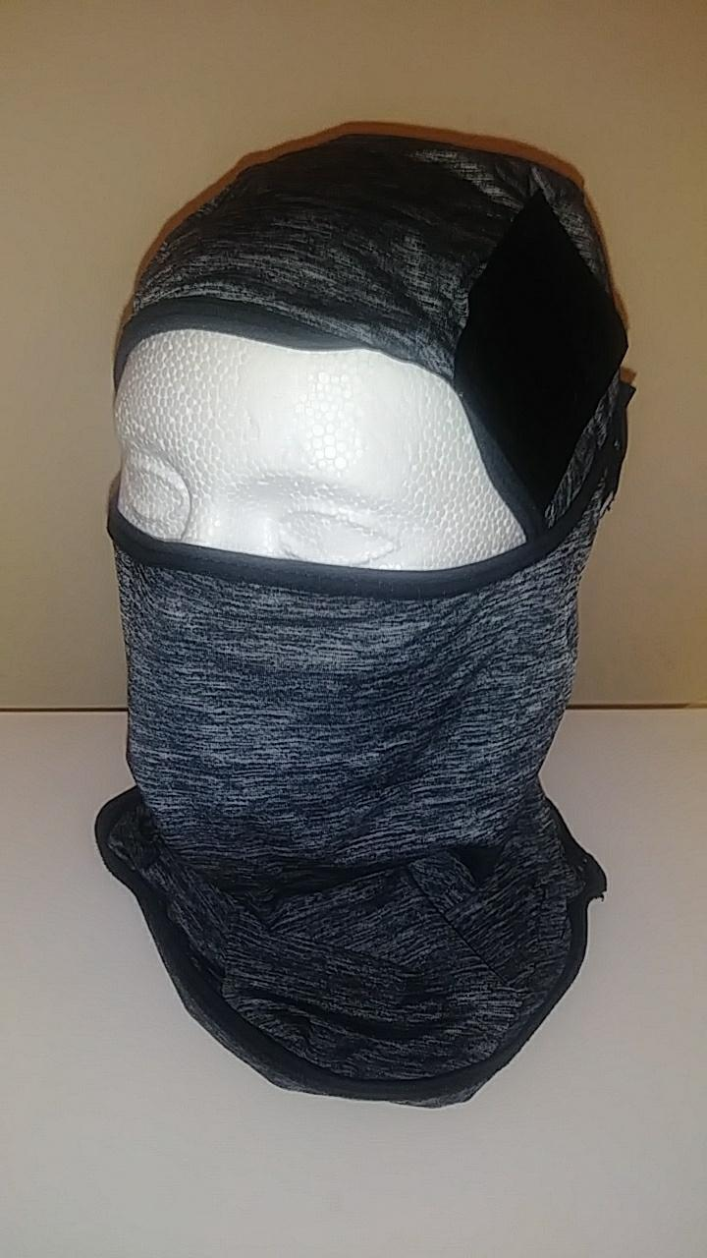

( Figure 1 ) Cooling mask used

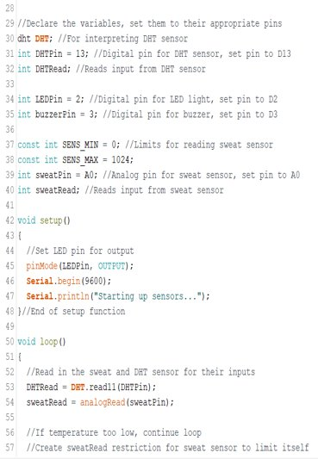Figure 2

Figure 3

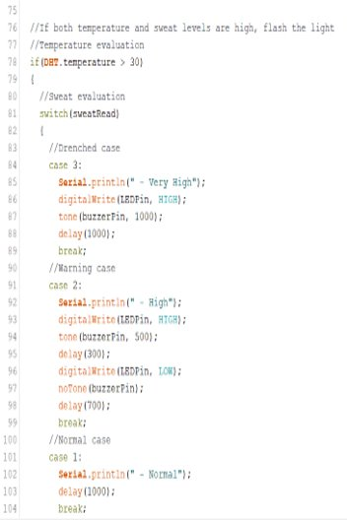Figure 4

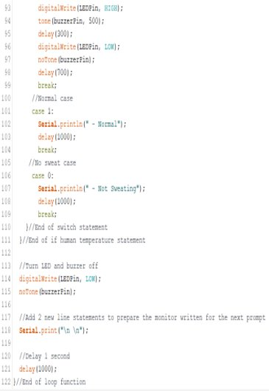Figure 5

Figure 2,3,4, and 5 shows code for the water sensor and Led light/Buzzer. When sweat hits the water sensor, the Led light/Buzzer goes off letting the user know that they are sweating too much and is in danger of breaking the VR headset.

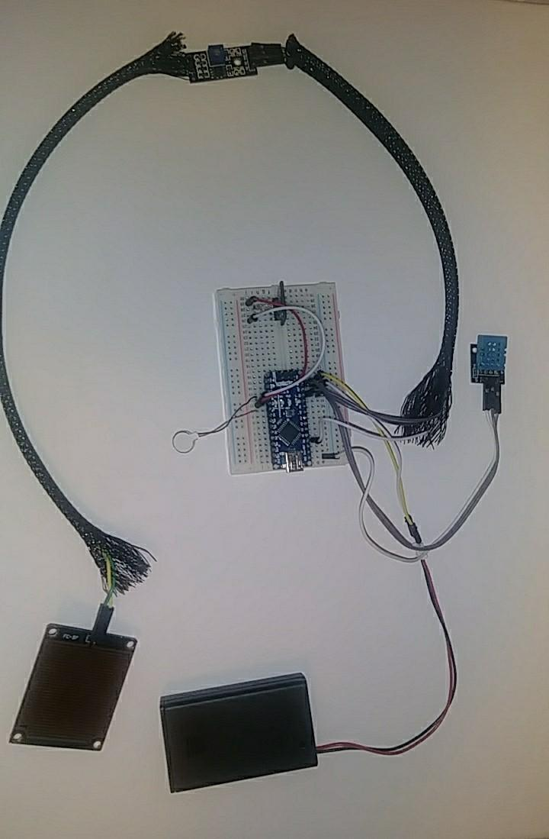(Figure 6)

Figure 6 shows the electrical components used

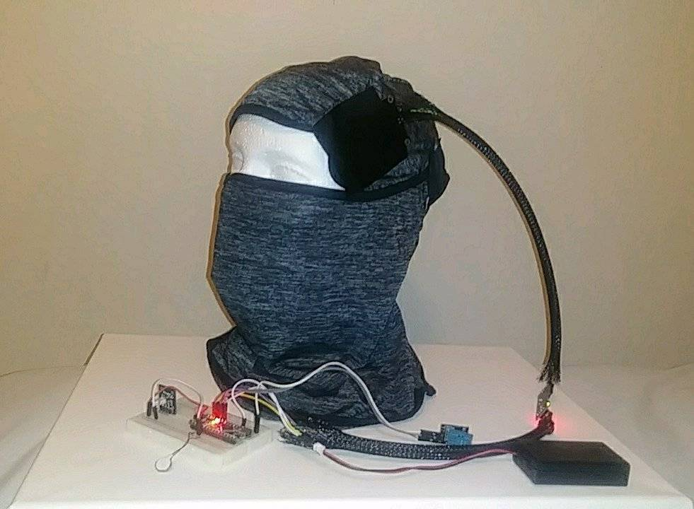(Figure 7)

Figure 7 shows finished product.

**Analysis/Discussion**

|  |  |  |  |
| --- | --- | --- | --- |
| Requirements | Sweat  Gladiator Mk 2 | Sweat  Gladiator | Vr  By itself |
| Inexpensive & Reusable | 2 | 2 | 0 |
| Must not limit mobility | 2 | 1 | 2 |
| Does not cause outgassing | 2 | 2 | 2 |
| Kills 95% of bacteria | 1 | 1 | 0 |

|  |  |
| --- | --- |
| 2 | Exceeds the requirements |
| 1 | Pass the requirements |
| 0 | Failed the requirements |

The Mk 2 sweat gladiator has improved and is clear that it is the best option out there meeting all requirements.

**Conclusion**

A Cooling Mask that can hold sweat with sensors that can warn the user when they are in danger of breaking the VR system is an incredible breakthrough. The device can let astronauts train longer without fear of damaging the technology. The device can also test the body. This can help in the medical field to learn more about the body while training, along with in space to learn about the effect of long periods of time in space on the human body. As more studies occur, there will be more research on better materials to use at a cheaper price. Continued testing will also allow the device to be as efficient in collecting sweat and cooling the user as possible.

**Acknowledgements**

* **Professor Nate Wiggins**: For guiding the team in the right direction and for providing our supplies.​
* **Cody(NASA Employee)-** For giving the team information about VR headsets and what NASA had already tried to solve the issue but failed
* **Shane Martin(Vynckier Intern)**- offered a place to work at, gave feedback, and gave points on how to present. ​
* **Previous Team:** **Josue Zuniga**- VR teams' leader, **Shane Martin**- VR teams 2nd in Command/lead designer/Researcher, **Osvaldo Rodriguez**- Hardware/Software researcher,  **Arnold Garcia**- Hardware researcher, **Diana Thomas**- Technical Writer​

**References**

* Bull, G. W. (2008, April 1). Cold Towels Valuable Rehab Tools. Retrieved April 28, 2019, from <https://www.fireengineering.com/articles/print/volume-161/issue-4/features/cold-towels-valuable-rehab-tools.html>​
* Corbett, J. (2017, August 6). Toxic Offgassing. Retrieved from ​  
  <https://www.nasa.gov/centers/wstf/testing_and_analysis/materials_flight_acceptance/toxic_offgassing.html>​
* Hall, J. E. (2016). Guyton and Hall Textbook of Medical Physiology (11th ed.). Philadelphia,PA: Elsevier. ​
* Honest. (2014, January 29). What Is Polyvinyl Alcohol? Retrieved April 28, 2019, from <https://blog.honest.com/polyvinyl-alcohol/>​
* NASA JSC. (2019). Wearable Technologies Workshop. Retrieved April 28, 2019, from <https://techcollaboration.center/wp-content/uploads/Workshops/WT_2019/Challenges/TCC_WT2019_Challenge-NASAJSC-VIVEVRSweatProtectionSensorCapability.pdf>​
* Outgassing Test Facility Brings New Materials into Space Industry. (n.d.). Retrieved from <https://spinoff.nasa.gov/Spinoff2017/ip_8.html>​
* Reede, E., & Bailiff, L. (2016). When Virtual Reality Meets Education. Retrieved April 28, 2019, from <https://techcrunch.com/2016/01/23/when-virtual-reality-meets-education/>​
* Rose, D. P., Ratterman, M., Griffin, D. K., Hou, L., Kelley-Loughnane, N., Naik, R. R., . . . Heikenfeld, J. (2014, November 6). Adhesive RFID Sensor Patch for Monitoring of Sweat Electrolytes. Retrieved April 28, 2019, from DOI 10.1109/TBME.2014.2369991​
* Goldfox Balaclava Face Mask, Retrieved july 10,2019 from<https://www.amazon.com/Balaclava-Protection-Incredibly-Breathable-Motorcycle/dp/B07R3JGDB6>​



